**EXPERIMENT-09**

**AIM-**To develop PLC Ladder Program using advanced instructions.

**EXERCISE**-

1) A 4-bit ADC is connected to I/P terminals 0,1,2,3.If start switch is ON, store analog I/P value in N7:3

If I/P level < 4 energises O/P 1

I/P level = 8 energises O/P 2

I/P level > 8 energises O/P 3

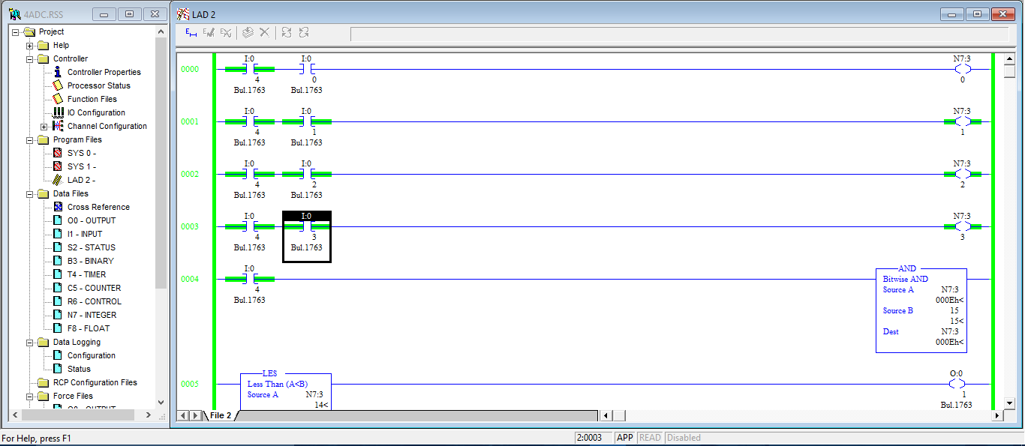

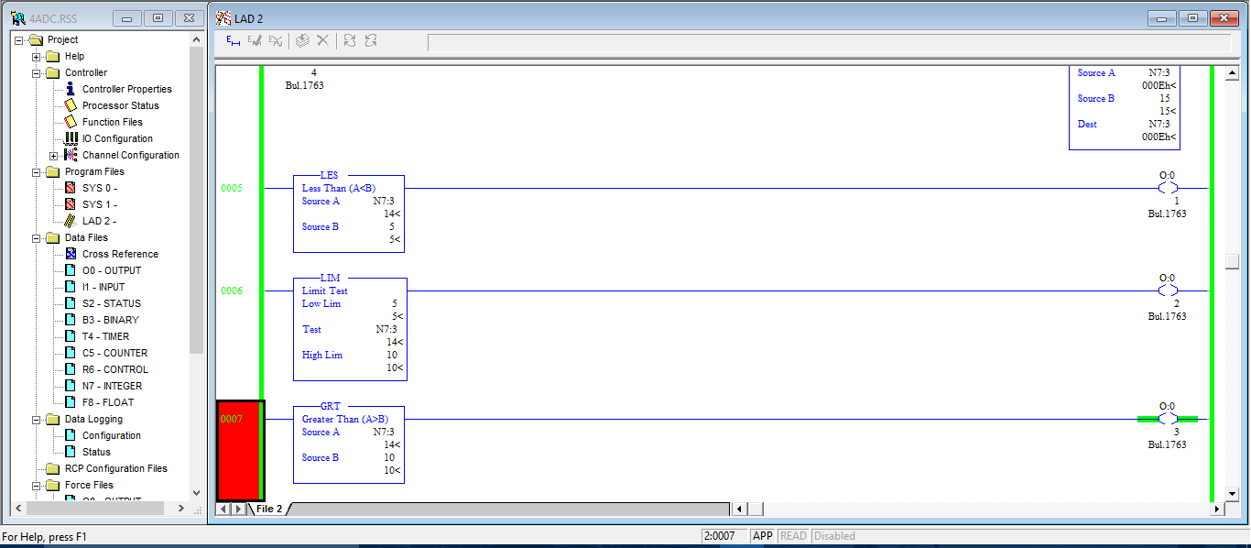

2) Following all the steps for ladder diagram construction, prepare PLC ladder diagram using RsLogix 500 software for following problem:

There are three conveyors which feed main conveyor.Counts of objecs on each conveyor is fed into I/P register in PLC. Obtain total counts & it updated every 1 hour.

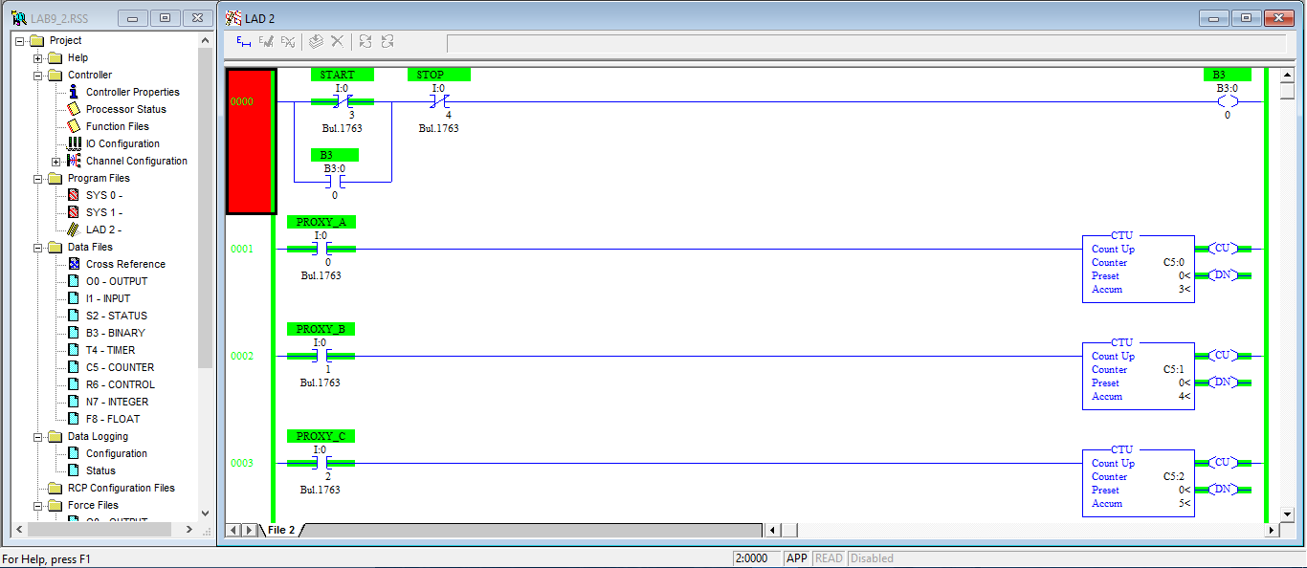

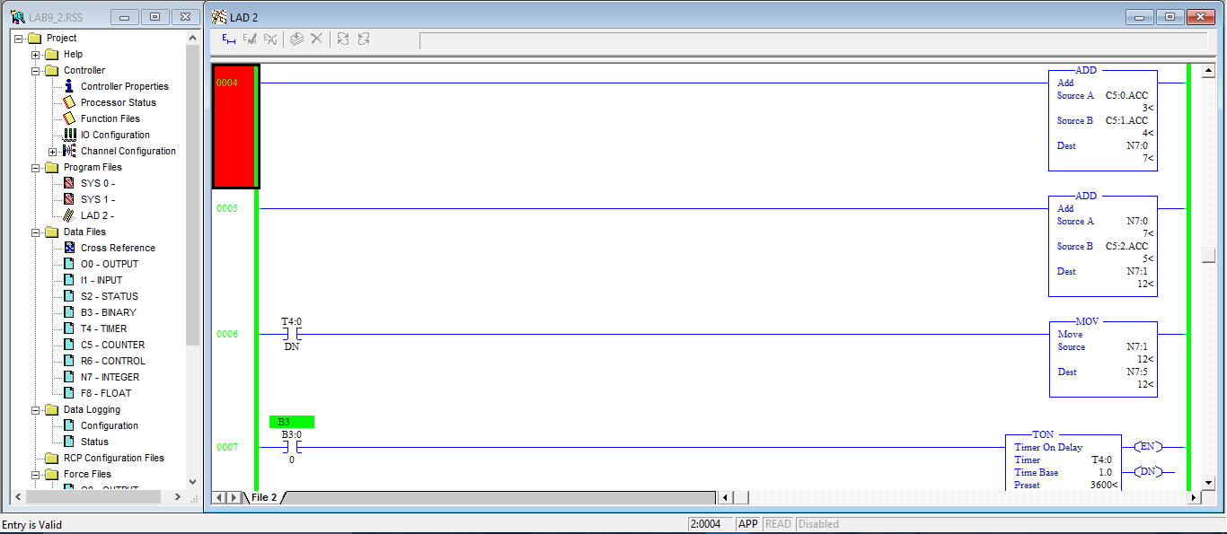

3) Following all the steps for ladder diagram construction, prepare PLC ladder diagram using RsLogix 500 software for following problem:

Conveyor A &B feed C. One more conveyor R removes short distanced products.Obtain total counts on C.

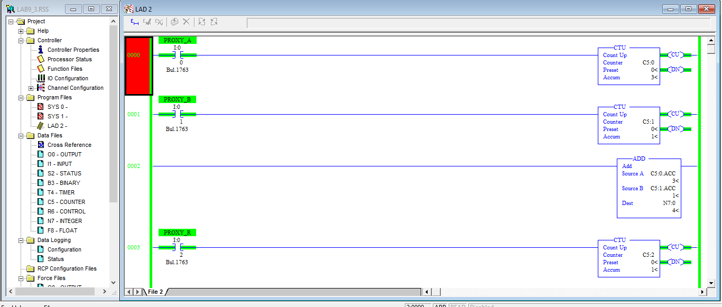

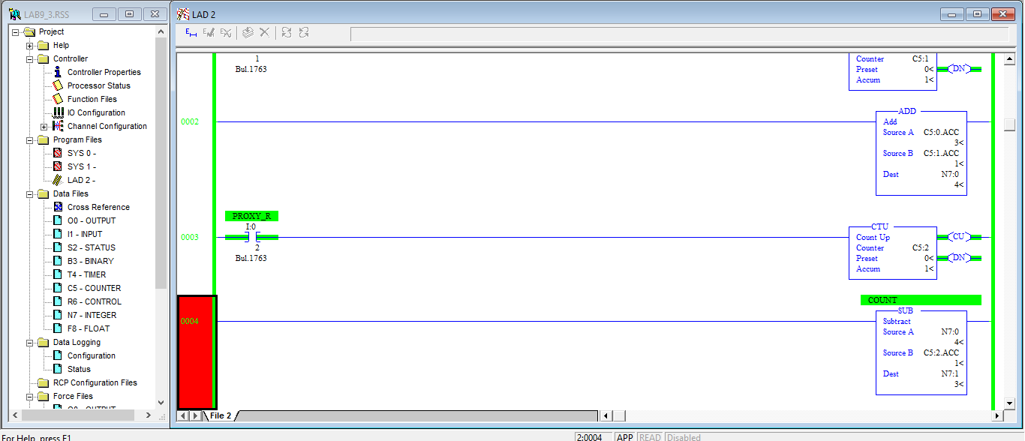

4) Draw a ladder diagram for the problem given below:

One O/P to go ON when I/P reaches 1.5 amp. Another O/P to go ON when I/P is between 1.8 &2.2 amp. Input range is 0-2.5 amp with 16 bit ADC.

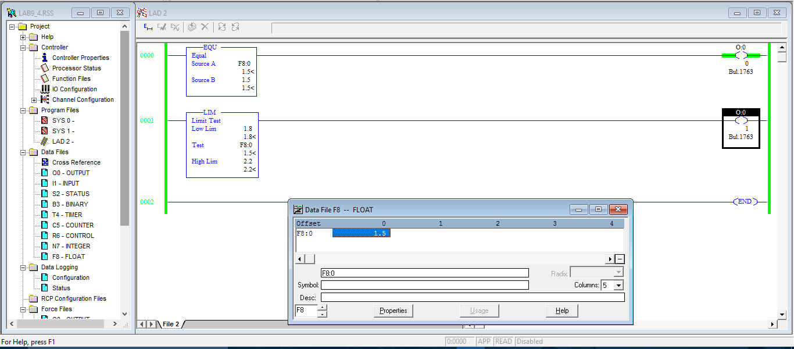

5) Draw a ladder diagram for the problem given below:

Make coolent pump ON if the temperature in a tank exceeds 80 degree centigrade.

